Electrical & Control Systems

Power Distribution System

Power Distribution
Our system consists of two main boards, the power board receives the 48 V through the tether.
power board is connected to the "48 V to 12 V" converters,
and the control board receives the 12v directly from a
"48v to 12v"converter. then distributing it to the system to convert 12v to required values of voltage (5v and 3.3v) for some other components, this process is done through our chosen structure as the voltages a redistributed using a minimum number of wires to ensure that the system is more stable and secure.

Power Conversion
Our system uses a 48 V power supply, then this volt is stepped down using 48 V to 12 V DC-DC converters with a total of 120 A. As our system requires smaller voltages, we use a 12V to 5 V DC step-down converter needed
Figure 1: Buck converter`
in several devices and the final conversion is to 3.3V.

Cameras
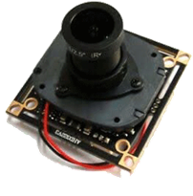
Draven is equipped with seven digital cameras with a 70-degree field of view to provide the pilots with excellent situational awareness and assist them in different ways to perform the ROV missions. Pilots can also record fairly good quality videos or take pictures up to 5 megapixels. There are 2 main cameras with a distance between them responsible for the primary vision for the ROV. They are placed in the front of the ROV. In addition to a camera on the top of the ROV that tilts down to view the two front grippers. Another camera is placed at the back of the ROV that has a clear view of the back gripper and the tether. And the last camera is used to view below the ROV and gives further perspective to what lays down the ROV.
Figure 13: CAIMAN-8's main camera

Tether System

Croco Marine decided to work with a new tether
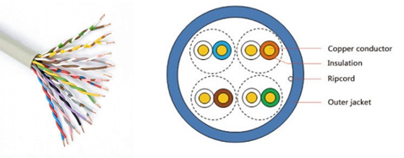
As digital cameres are used instead of analog ones therefore camera cables (cat6) won't be used. The last year our engineers pioneered a design for the tether and enhanced it drastically. They designed it such that it's one cable for both power and data. The cable is 10.6 mm in overall diameter, 4.5 kg.Transmitting signal and power over one cable was never an easy target. However, we managed to reduce noise interfere necereasonably by applying noise control. When it comes to connectors, D-sub is our optimum connector for signal and XT60 for power.
Figure 14: Cross-section of CAIMAN-8's tether

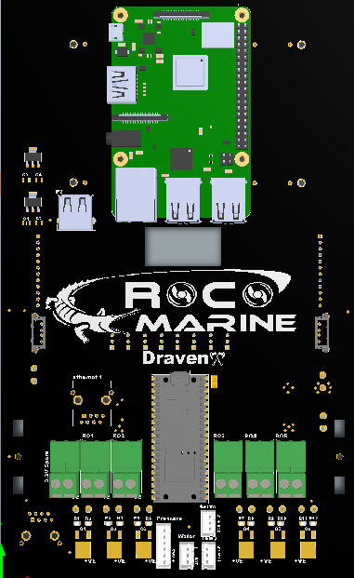
control board

control board Is considered as the brain of our system, the control board gets Its power directly from "48v to 12v" converter. then part of 12v power is send to stepdown converter to get 5v and 3.3v In the same board .the system is being controlled through raspberry pi which Is connected to raspberry pico to control and communicated the other devices.

as many cameras are need so camera hubs are used. hubs get the power from the control board and being controlled from raspberry pi not to make load on the raspberry pi.

If some components or devices are needed to be added. sheild Is used and Is connected to 12v ,5v ,3.3v and spare terminal blocks and gets the signal from the pico.

3.3v Is got from a regulator ams1117. this volt Is need to operate the pressure sensor
5v Is got from dc to dc converter xl4016. this volt Is need to operate camera hubs and water sensor and raspberry pi 12v Is got from buck converter and Is need to operate the xl4016 converters and dcv and leds and Spare Terminal blocks are used If more power Is needed

SENSORS

DOF SENSOR (ADAFRUIT BNO055 ABSOLUTE ORIENTATION SENSOR)
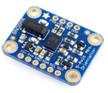
To detect the "3D space orientation" of our system, we use the sensor fusion algorithms, which include MEMS gyroscope, accelerometer, magnetometer, and advanced mathematics to get accurate orientation data. And BNO055 absolute orientation sensor provides us with the sensor fusion mode using a high-speed ARM Cortex-M0-based processor. By getting the orientation data from BNO055 and applying the Proportional, integral, and derivative (PID) controller. This should tend to be more reliable to control physical systems and adjust when the system fails to be in an expected stable mode.
Figure 20: ADAFRUIT BNO055 absolute orientation sensor

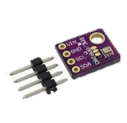
Pressure sensor (bmp280)
It is used pressure sensor to know the depth of the rov and control it.
It uses spi connection. and it suitable as doesnot consume much energy and donot
Need much space

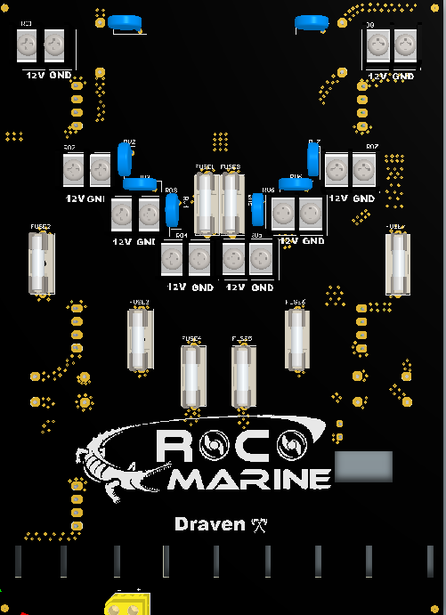
POWER BOARD
Power board is considered the main board of the hardware system as it contains the majority of the power conversion from 48V to 12V which is done through 6 DC-DC “48V to 12V” converter which is connected to the thruster’s power interface in addition to receiving the thrusters’ signal from the control board and send it through data connector.

Topside Control Unit
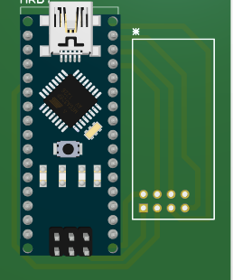
CrocoMarine’s engineers have developed a station that
handles draven's wiring, control, and power while taking into
consideration that our station must be of considerably small size and
not bulky to be portable. It is equipped with an LCD that is responsible
for the pilot’s main view. The LCD is connected through an HDMI
cable to a DVR to display the camera’s view.
Moreover, there are two laptops, the main is used to provide
the co-pilot with all the specific software tools needed in missions
using a Graphical User Interface (GUI) software system which provides
the pilot and the co-pilot with the capability of controlling thrusters’ motion and showing motion types, speed levels, the position of the ROV and many other helpful tools while the image processing tools are shown on the secondary laptop.

we used an arduino nano to control the station board and nrf to send and receive informaiton from the rov and it will get its power from the labtop

Power consumption

 |  | Maximum power consumption
Components | Quantity | Normal Voltage  (V) | Max current  (A) | Power per component (W) | Total Max Power (W)
Thrusters (T200) | 8 | 12 | 8 | 96 | 768
Cameras | 8 | 5 | 0.3 | 1.5 | 12
Dc motor (Optional) | 2 | 12 | 5 | 60 | 120
Raspberry pico | 1 | 5 | .3 | .15 | .15
Raspberry pi | 1 | 5 | 3 | 1.5 | 1.5
IMU | 1 | 3.3 | 0.3 | 0.99 | 0.99
Temperature Sensor | 1 | 5 | .0015 | .0075 | .0075
Solenoid | 4 | 12 | 0.303 | 3.636 | 14.544
Total Maximum Power (Watt) | 917.192
Total Current (A) | 17.203
Total Power Supply (Watt) = 48 (V) * 30(A) | 1440
Fuse Value | 30 A

$$Fuse calculations \left(main ROV\right)= \frac{F.O.S * Total Maximum Power}{Mate Supply Voltage}=\frac{150\%*917.192}{48}= 28.662 A$$

